Slow Learners (2021-22)
BA/B.ScSem II
Name of Student | Roll No | Class | Marks in House test out of 20 | Remedial Measures Taken | Outcome/ Achievement(marks in May UNIV. Exam, 2022) | Proofs
Shaveta Sharma | 21107 | B.Sc (NM) Sem II | 5 | Re-explanation of difficult and important topics, encouragement to self preparing notes, style to attempt the university question paper in fully taught so that students can improve their subject skills by taking extra classes on holidays and in free periods. | 40/100 | 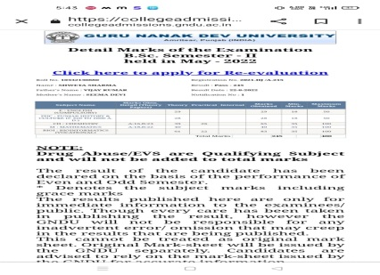
Rohini | 21108 | B.Sc (NM) Sem II | 6 |  | 38/100 | 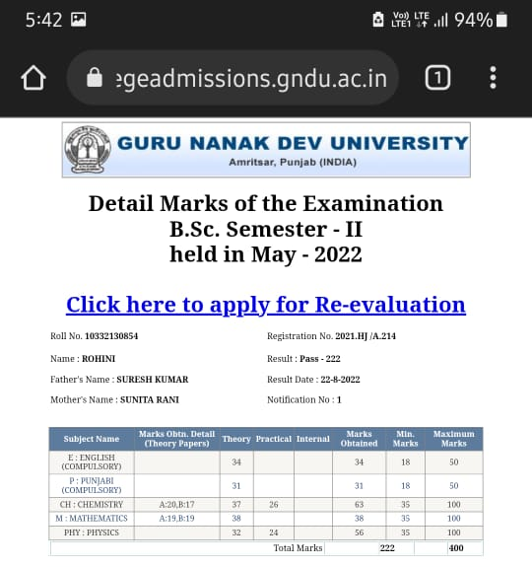
NandiniKumari Singh | 21125 | B.Sc (NM) Sem II | 5 |  | 40/100 | 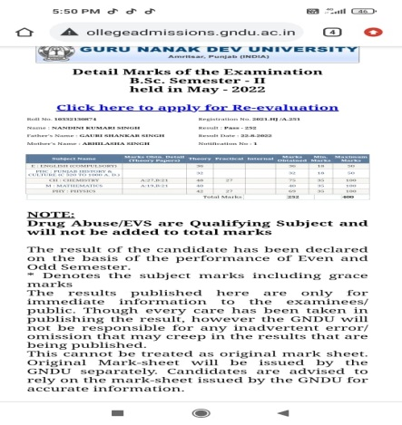
Kajaldevi | 21126 | B.Sc (NM) Sem II | 4 |  | 42/100 | 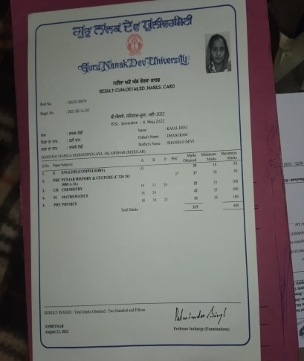
Parul | 22110 | B.Sc (CS) Sem II | 6 |  | 38/100 | 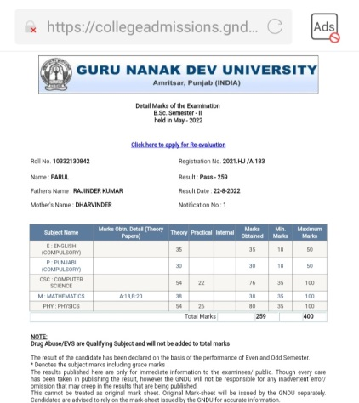
Priyakumari | 22113 | B.Sc (CS) Sem II | 6 |  | 36/100 | 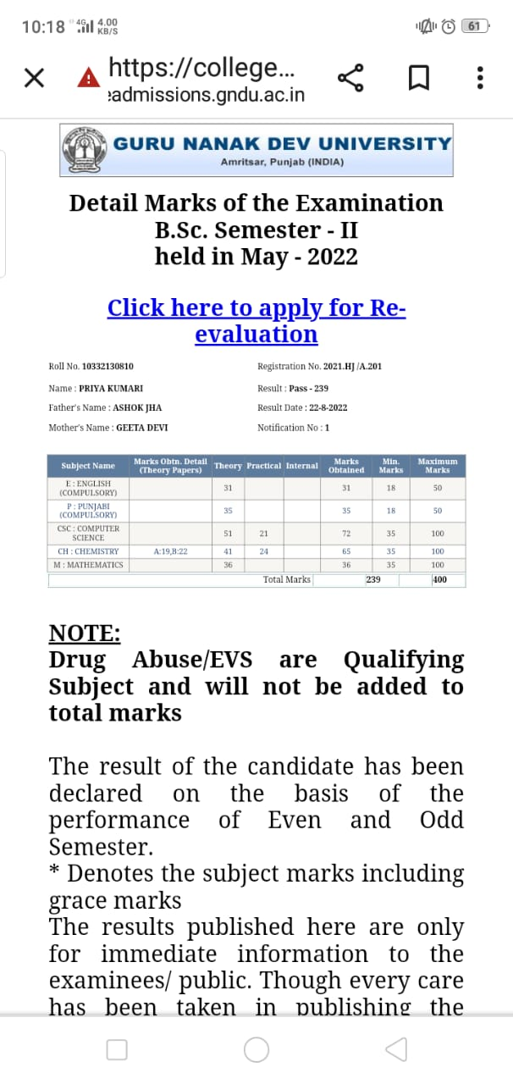
Amanjot | 22117 | B.Sc (CS) Sem II | 5 |  | 40/100 | 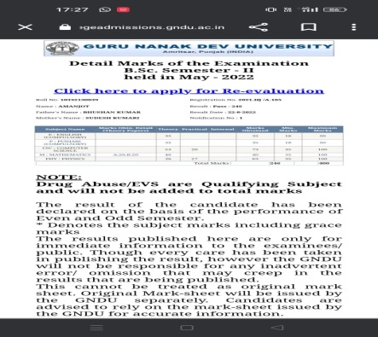
Nourin | 22120 | B.Sc (CS) Sem II | 5 |  | 39/100 | 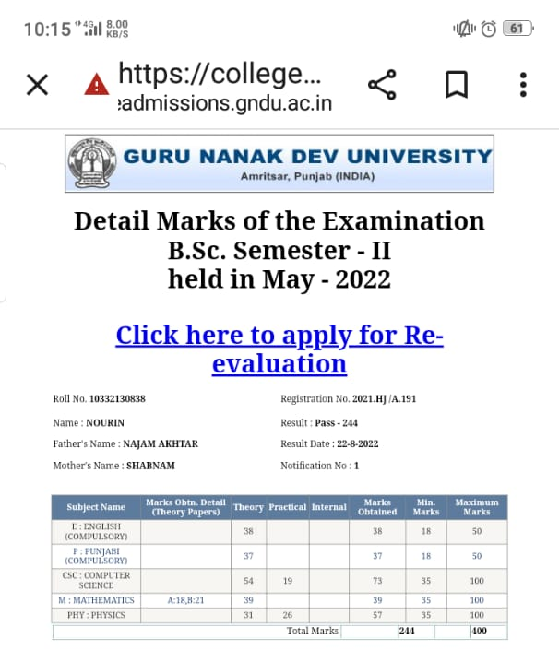
Roshni | 22122 | B.Sc (CS) Sem II | 6 |  | 36/100 | 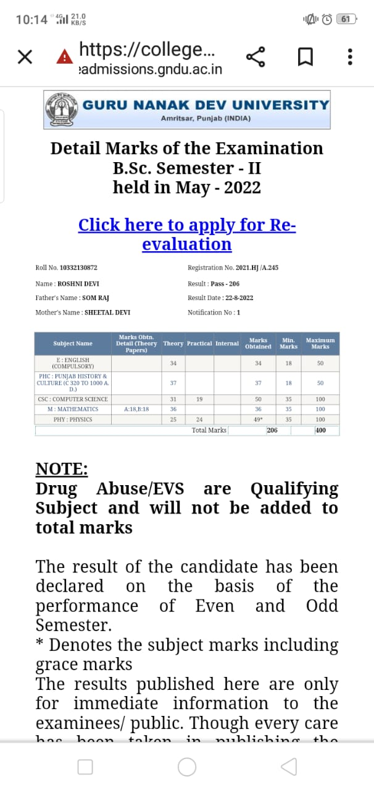
Radhika | 22123 | B.Sc (CS) Sem II | 5 |  | 36/100 | 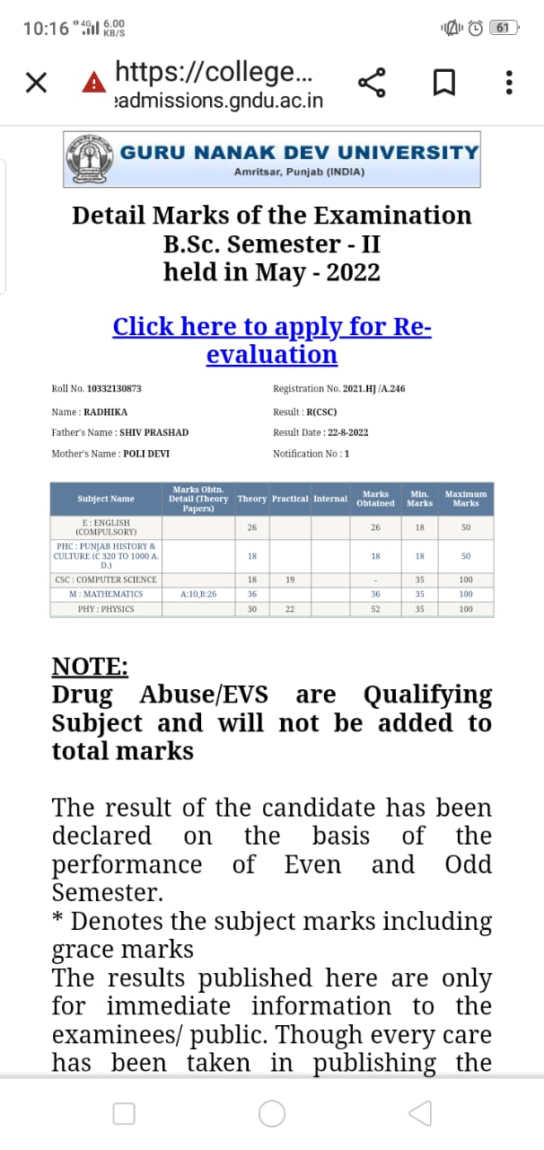

BA/B.ScSemIV
Name of Student | Roll No | Class | Marks in House test out of 20 | Remedial Measures Taken | Outcome/ Achievement (marks in May UNIV. Exam, 2022) | Proofs
Kamaljeetkaur | 10151 | B.ASemIV | 9 | Re-explanation of difficult and important topics, encouragement to self preparing notes, style to attempt the university question paper in fully taught so that students can improve their subject skills by taking extra classes on holidays and in free periods. | 46/100 | 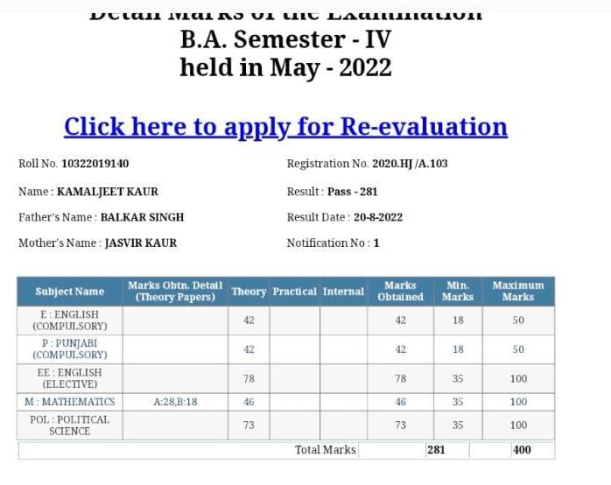
Vaani | 10183 | B.ASemIV | 0 |  | 45/100 | 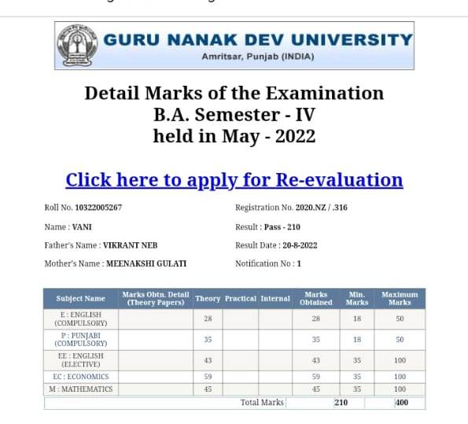
PallaviBains | 21030 | B.Sc (NM) SemIV | 5 |  | 35/100 | 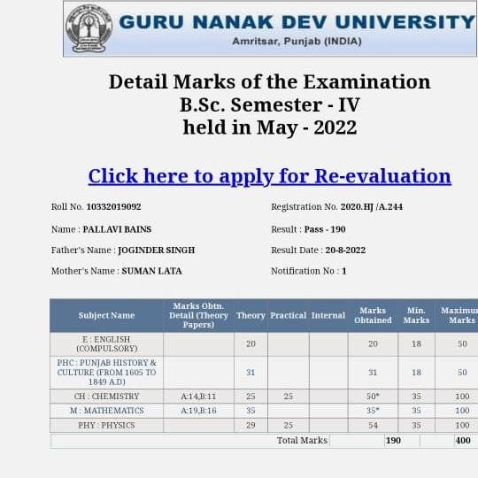
Muskan | 21025 | B.Sc (NM) Sem IV | 13 |  | 39/100 | 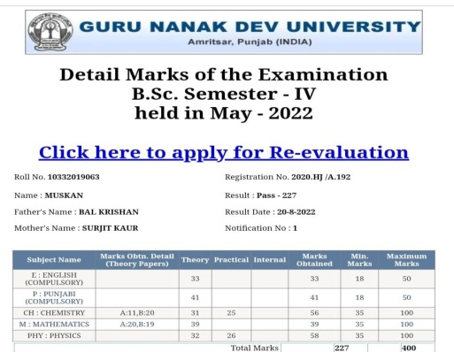
Poonama | 10087 | B.ASemIV | 9 |  | 37/100 | 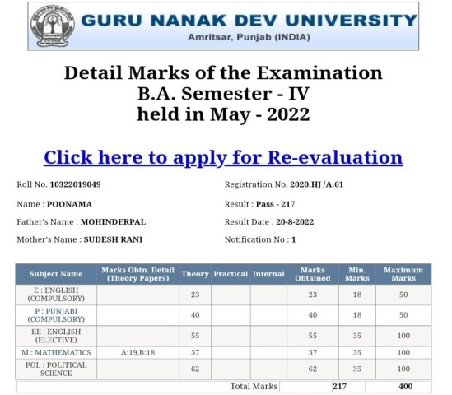
Pooja Rani | 12015 | B.Sc (Eco) SemIV | 12 |  | 40/100 | 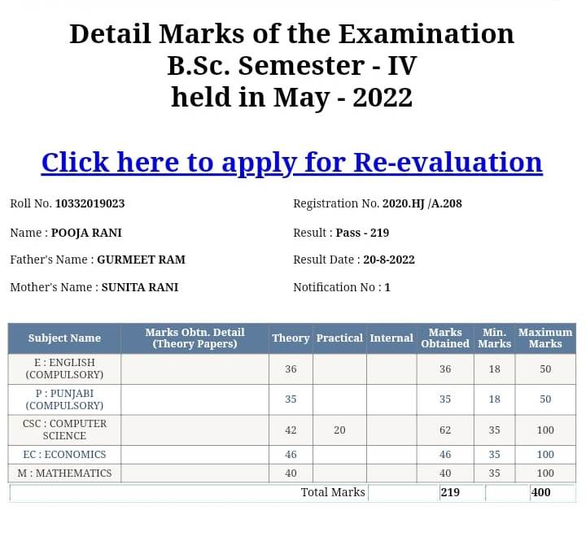
Pallavi | 22029 | B.Sc (CS) SemIV | 5 |  | 35/100 | 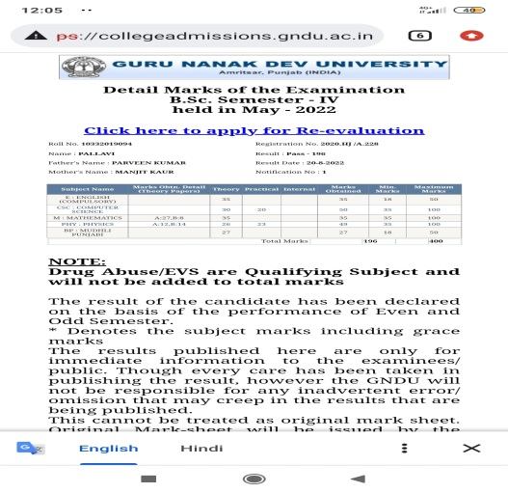
Suneha | 22012 | B.Sc (CS) SemIV | 7 |  | 35/100 | 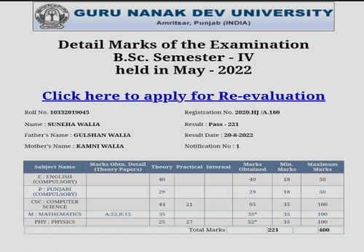
Khushi | 22009 | B.Sc (CS) SemIV | 7 |  | 39/100 | 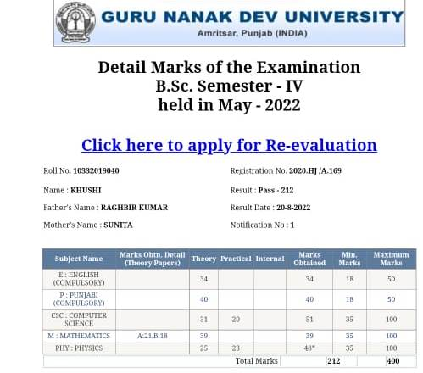
Kriti | 22002 | B.Sc (CS) SemIV | 12 |  | 41/100 | 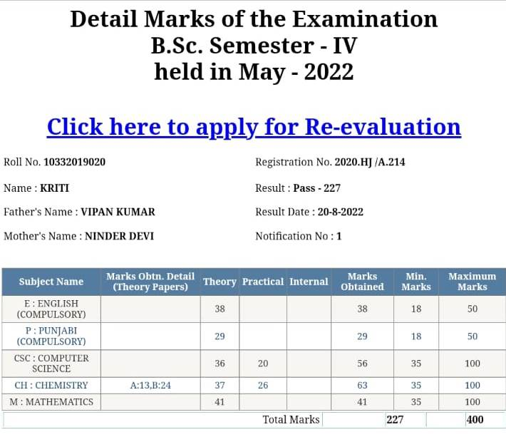

BA/B.ScSem VI
Name of Student | Roll No | Class | Marks in House test out of 20 | Remedial Measures Taken | Outcome/ Achievement (marks in May UNIV. Exam, 2022) | Proofs
RitikaBhagat | 6814 | B.Sc (NM) SemVI | 4 | Re-explanation of difficult and important topics, encouragement to self preparing notes, style to attempt the university question paper in fully taught so that students can improve their subject skills by taking extra classes on holidays and in free periods. | 40/100 | 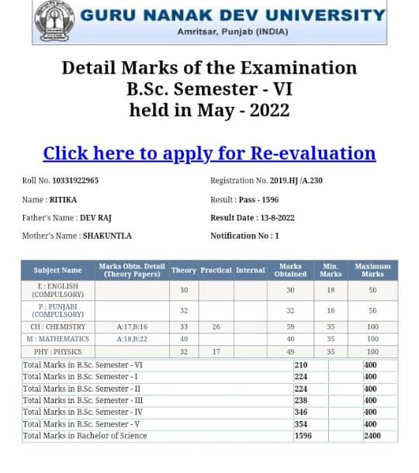
JasleenKaur | 6816 | B.Sc (NM) SemVI | 6 |  | 40/100 | 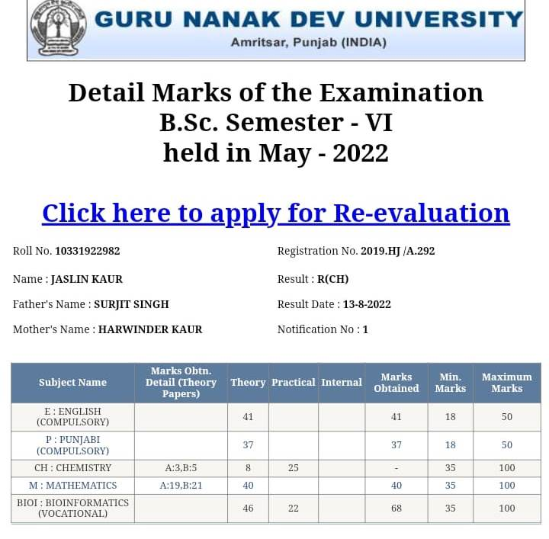
Harpreet | 6937 | B.Sc (CS) SemVI | 7 |  | 40/100 | 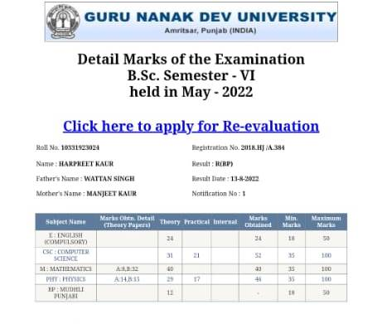
Harman | 6934 | B.Sc (CS) SemVI | 6 |  | 48/100 | 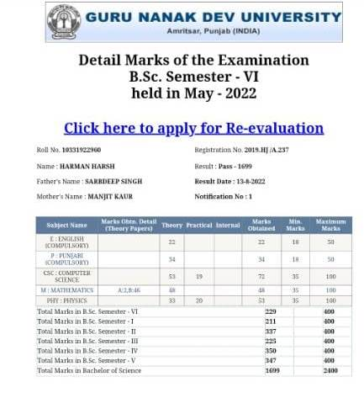
Neelu | 6928 | B.Sc (CS) SemVI | 6 |  | 36/100 | 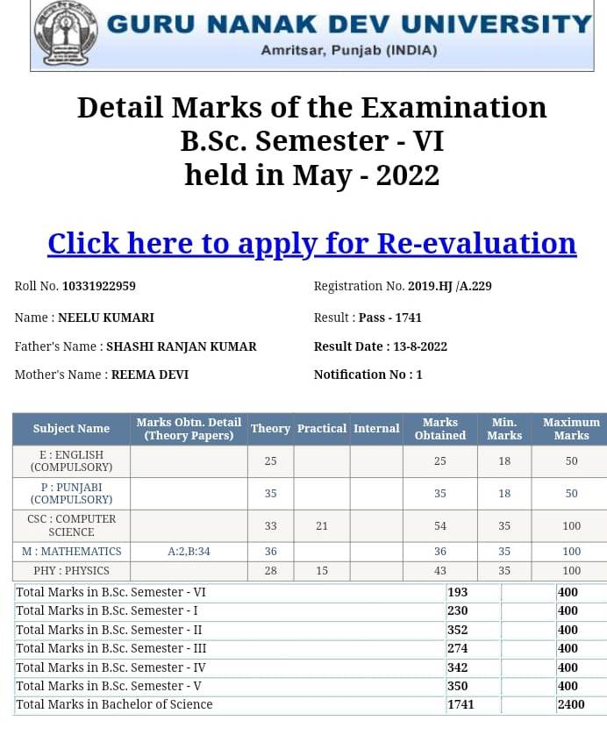

M.ScSemIV
Name of Student | Roll No | Class | Marks in House test out of 40 | Remedial Measures Taken | Outcome/ Achievement (marks in May UNIV. Exam, 2022) | Proofs
Vyomika | 25413 | M.ScSem IV | 25 | Re-explanation of difficult and important topics, encouragement to self preparing notes, style to attempt the university question paper in fully taught so that students can improve their subject skills by taking extra classes on holidays and in free periods. | 1381/2000 | 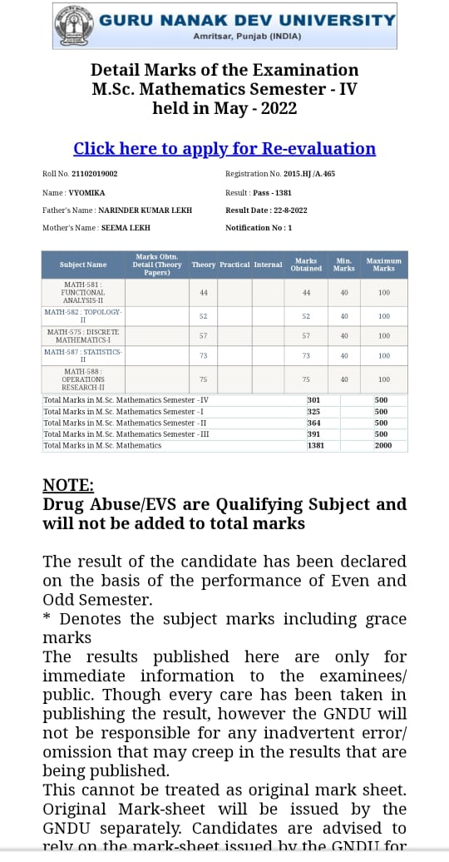

M.Sc. Sem II
Name of Student | Roll No | Class | Marks in House test out of 40 | Remedial Measures Taken | Outcome/ Achievement (marks in May UNIV. Exam, 2022) | Proofs
Sunena | 25464 | M.ScSem II | 28 | Re-explanation of difficult and important topics, encouragement to self preparing notes, style to attempt the university question paper in fully taught so that students can improve their subject skills by taking extra classes on holidays and in free periods | 249/500 | 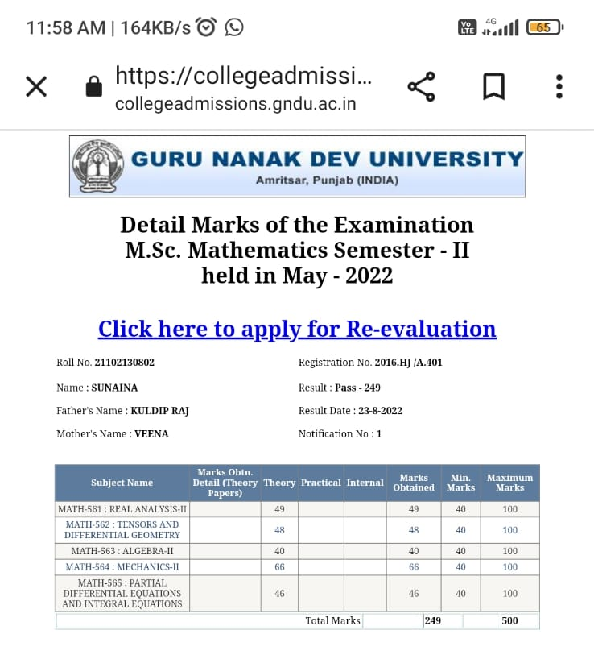
Sucheta rani | 25461 | M.ScSem II | 30 |  | 209/500 | 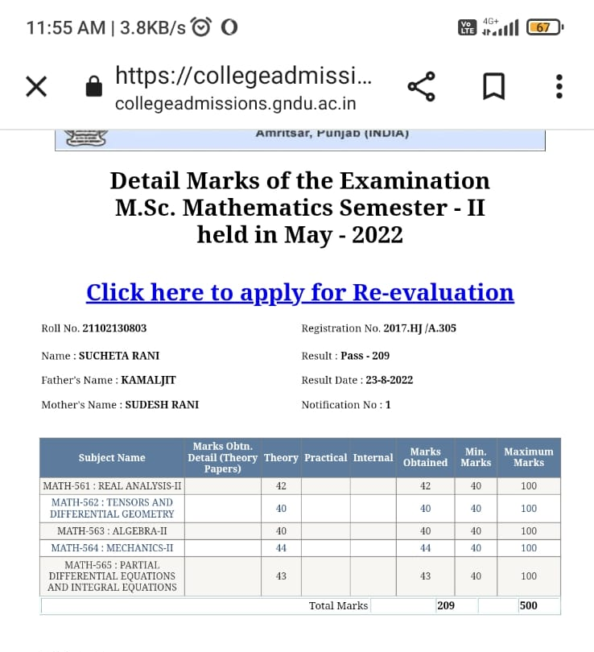
GuneetKaur | 25455 | M.ScSem II | 28 |  | 209/500 | 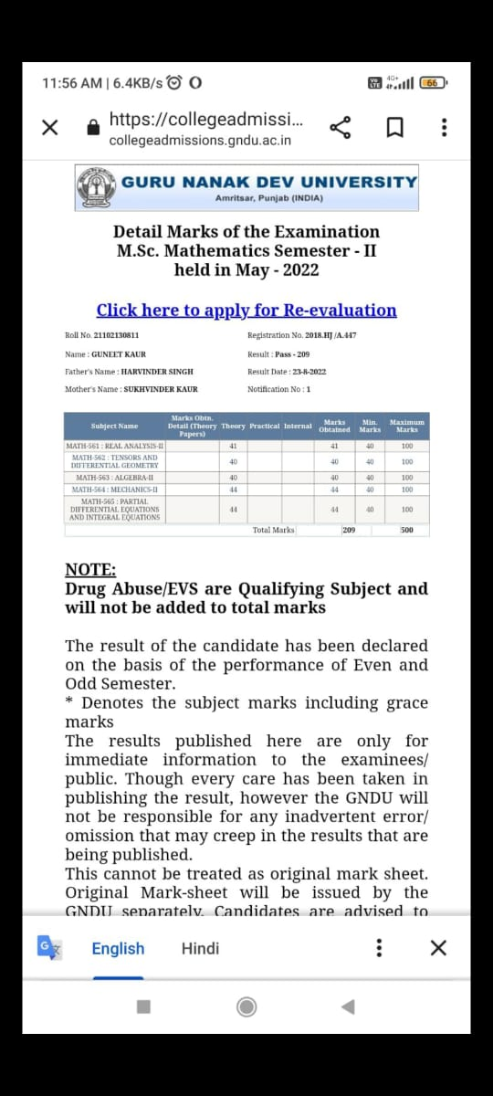
Muskan Gupta | 25458 | M.ScSem II | 29 |  | 247/500 | 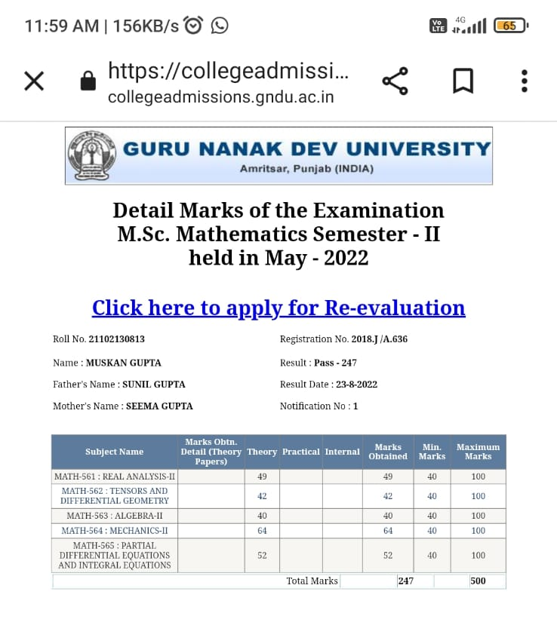

B.Sc (ECO) Sem II (Subject: Quantitative Techniques)
Name of Student | Roll No | Class | Marks in House test out of 20 | Remedial Measures Taken | Outcome/ Achievement (marks in Feb. UNIV. Exam, 2022) | Proofs
KhusnhnoorUbhee |  | B.Sc (Eco) SemII | 8 | Re-explanation of difficult and important topics, encouragement to self preparing notes, style to attempt the university question paper in fully taught so that students can improve their subject skills by taking extra classes on holidays and in free periods. | 89/100 | 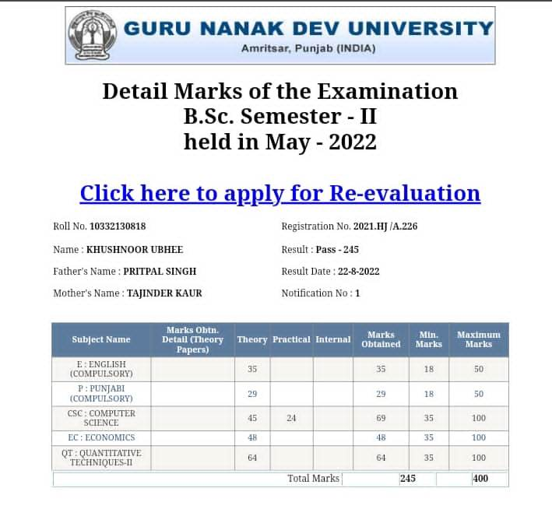
Kashish |  | B.Sc(Eco) SemII | 6 |  | 83/100 | 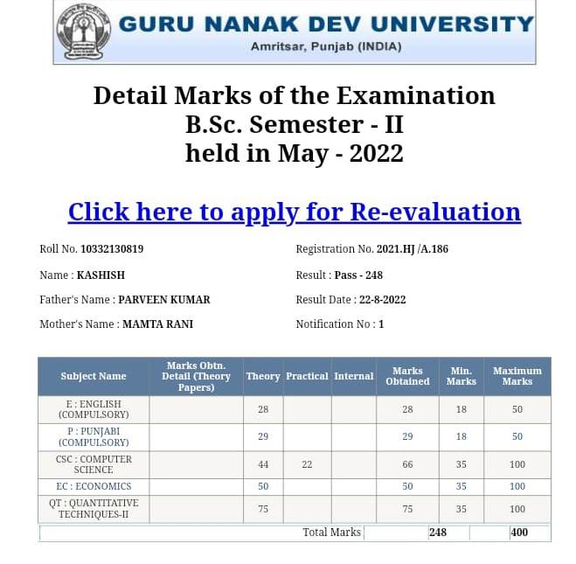
GeetikaChugh | 21125 | B.Sc (Eco) SemII | 5 |  | 77/100 | 